**TECHNO ENGINEERING COLLEGE BANIPUR**

**POSTER MAKING ON ENERGY CONSERVATION**

**POSTER MAKER: ARNAB CHAKRABORTY**

**Dept: ECE. University roll no. 24400318021**

Energy conservation is the effort made to reduce the consumption of energy by using less of an energy service. This can be achieved either by using energy more efficiently or by reducing the amount of service used. Energy conservation is a part of the - concept of Eco-sufficiency.

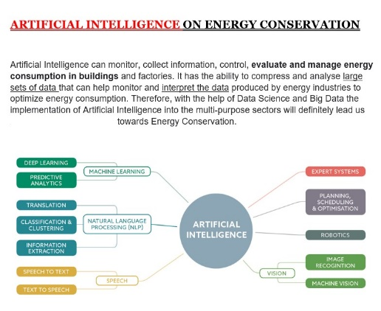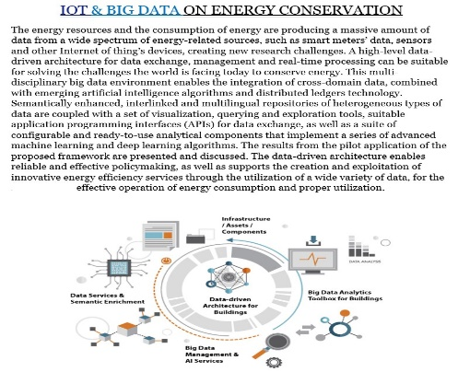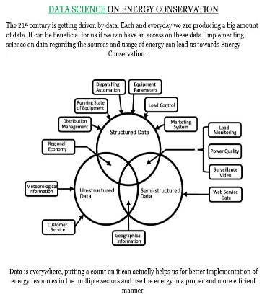

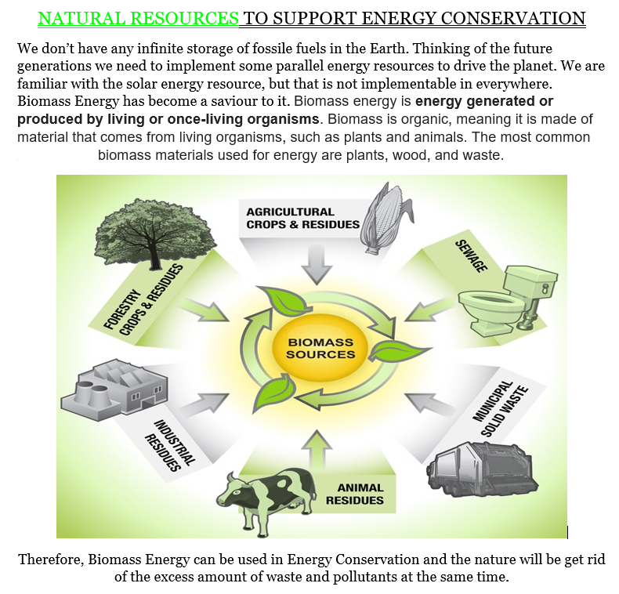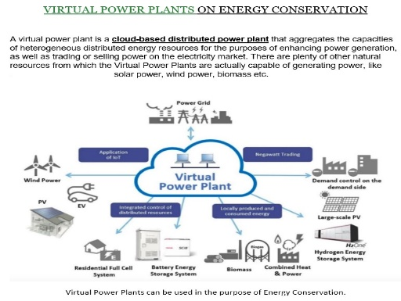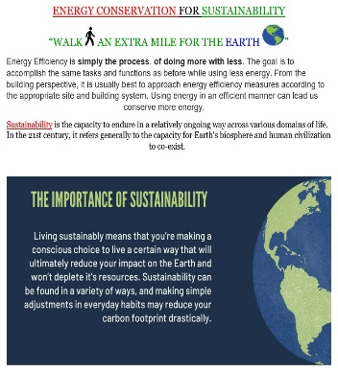

Energy plays a crucial role in modern societies. It has a vital input to all sectors (e.g., residential, transportation, and manufacture) and **is essential to generate electricity**. In other words, all societies require energy services to meet basic human needs such as lighting, heating, and mobility. Therefore, to conserve energy and use it in an efficient manner is our - utmost duty and responsibility.